SIMPLE RECIPE COLLECTION & MEAL PLANNER
@CREATIVITY THINK (9483175986/7019689991)

ABSTRACT:
Simple Recipe Collection & Meal Planner is a web-based application designed to help home cooks, hostel messes, and small canteens organize recipes, plan weekly meals, and generate shopping lists. The platform allows users to browse and search recipes, save favorites, plan meals on a calendar, auto-generate shopping lists, rate recipes, and view meal history. Administrators manage recipe databases, categories, user submissions, and monitor analytics for popular recipes and meal planning efficiency. Built with Django and Django REST Framework for backend services, and React with Redux and axios for frontend interactions, the system provides a structured and user-friendly approach to meal planning and recipe management..

INTRODUCTION OF THE PROJECT:
Managing recipes and planning meals can be time-consuming and error-prone when done manually. Small kitchens, hostel messes, or individual cooks often struggle to organize recipes, track favorites, and plan weekly meals effectively. Simple Recipe Collection & Meal Planner addresses these issues by offering a centralized, interactive platform for recipe browsing, meal scheduling, shopping list generation, and feedback collection. The system streamlines meal planning, enhances organization, and improves user experience through structured data and analytics..

PROJECT OBJECTIVES:

• Provide a centralized system to browse and manage recipes
• Allow users to save favorite recipes for quick access
• Enable weekly meal planning with a calendar interface
• Auto-generate shopping lists based on planned meals
• Allow users to rate and review recipes
• Track meal history and past planning for reference
• Enable administrators to add, edit, and categorize recipes
• Moderate user-submitted recipes and ensure quality
• Provide analytics on popular recipes and meal trends
• Export meal planning statistics for operational review

PROBLEM OF THE STATEMENT:
Home cooks, small canteens, and hostels often face challenges in maintaining organized recipes, planning meals in advance, and tracking ingredients. Traditional methods such as handwritten notes, spreadsheets, or scattered apps are inefficient and prone to errors. Simple Recipe Collection & Meal Planner provides a digital solution where recipes are organized, meal plans are structured, shopping lists are automatically generated, and analytics help administrators optimize recipe management and meal planning..

MOTIVATION OF THE PROJECT:
• To simplify recipe organization and retrieval
• To enable efficient weekly meal planning
• To automate shopping list creation and reduce manual errors
• To allow users to rate, review, and track meals
• To provide administrators with structured control over recipes and categories
• To analyze user preferences and meal trends for better planning
• To enhance user engagement and satisfaction
• To offer a responsive, intuitive interface for both users and admins

BLOCK DAIGRAM OF PROJECT:

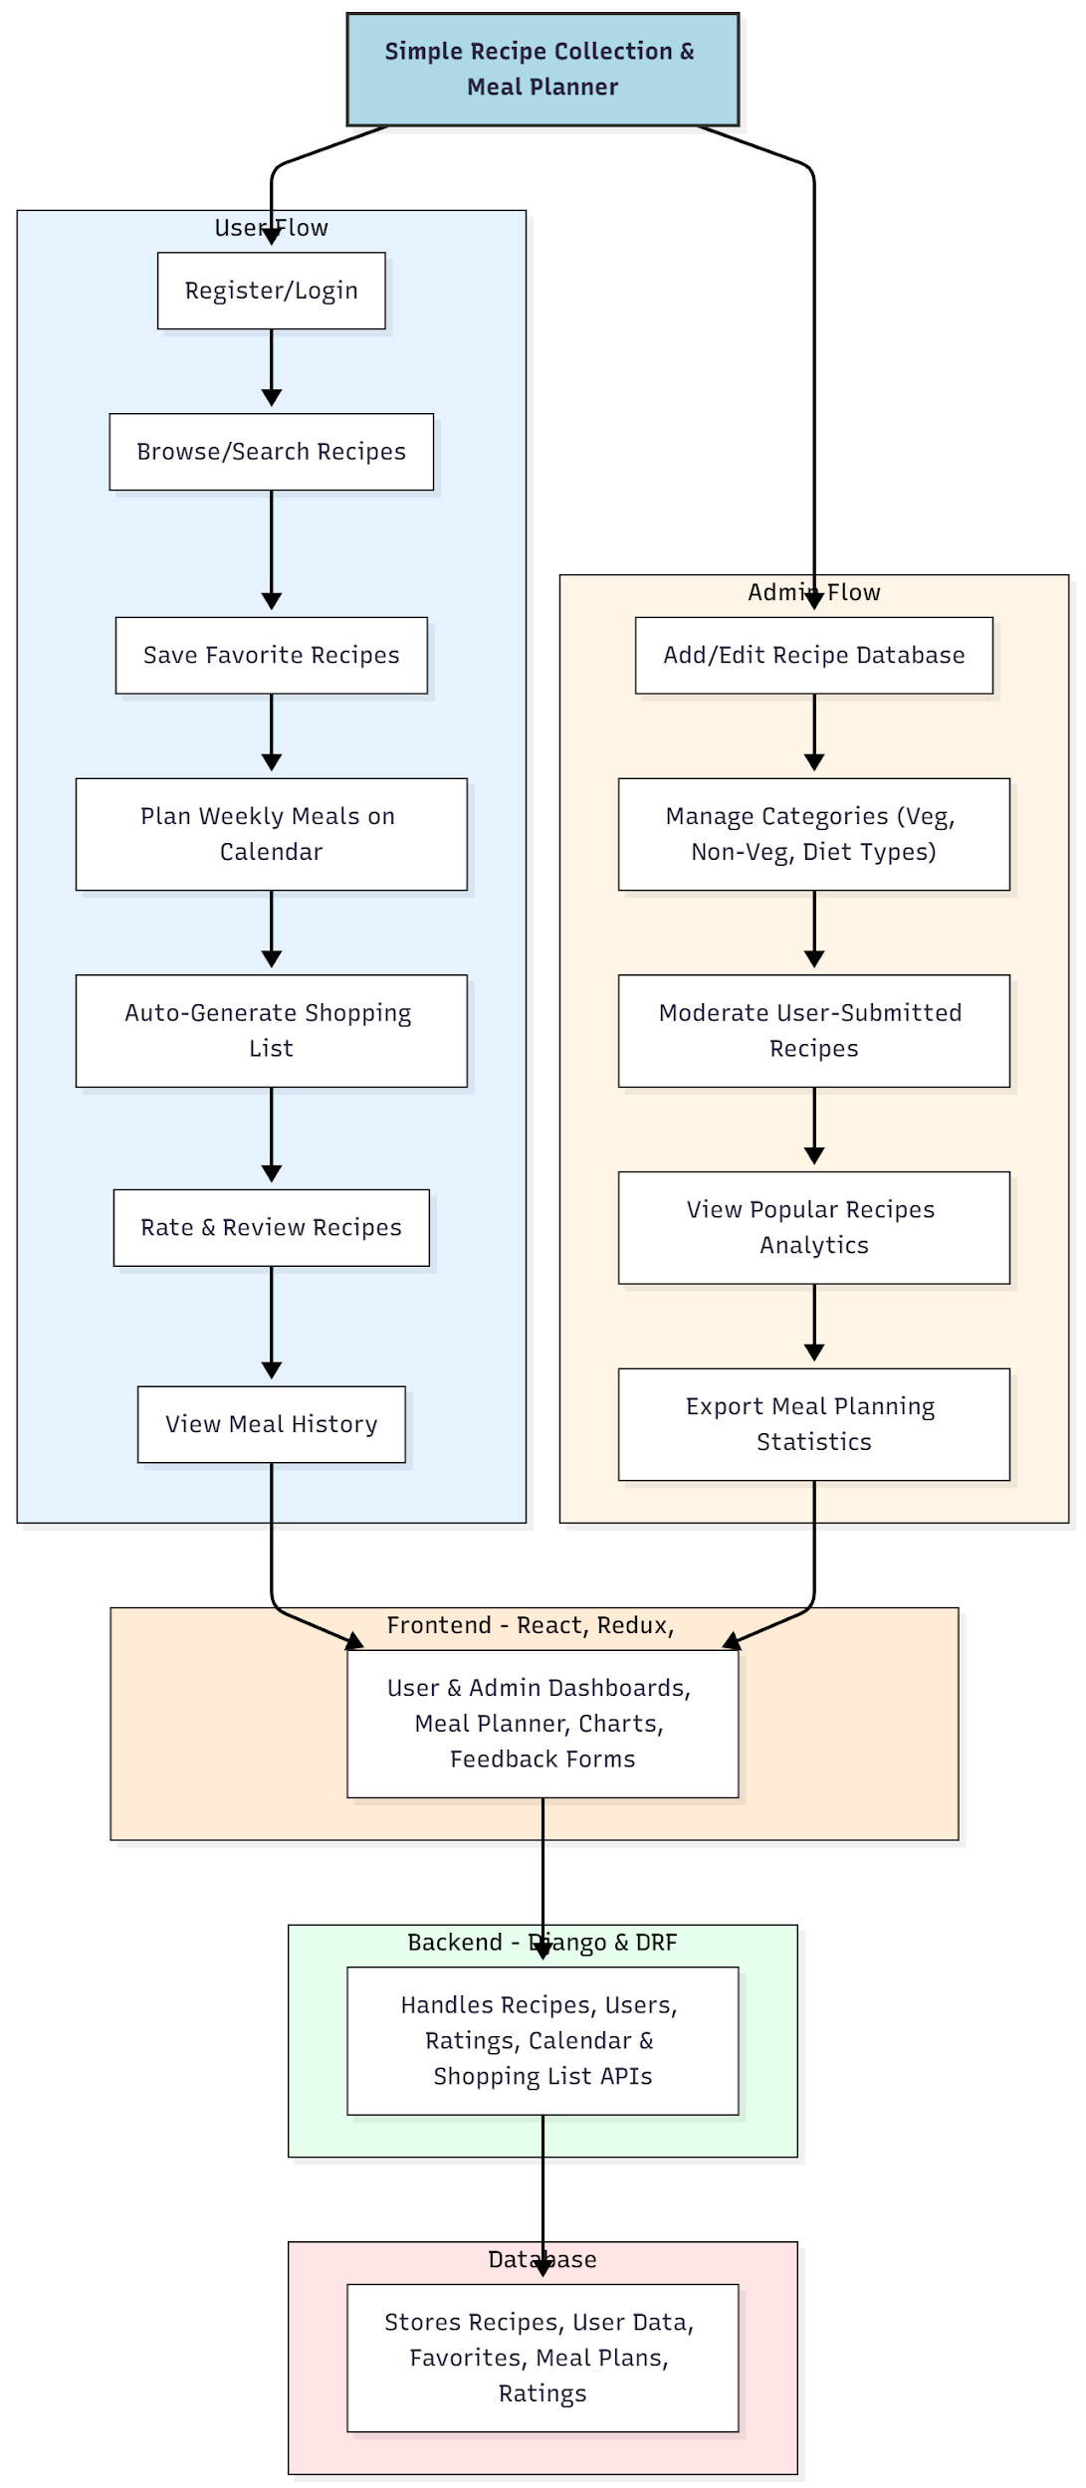

WORKING OF THE PROJECT:
Users register or log in to the system to browse and search recipes by category or keyword. They can save favorite recipes, plan meals on a weekly calendar, and automatically generate shopping lists based on selected recipes. Users can rate and review recipes, as well as track their meal history for reference.
Administrators manage the recipe database, categorize dishes, moderate user submissions, monitor analytics on popular recipes, and export meal planning statistics. The backend handles API requests, stores structured data, and ensures real-time updates on the frontend. This workflow provides an organized, interactive, and efficient platform for meal planning and recipe management..

SOFTWARE REQUIREMENT:
- Backend:
  - Python 3.x
  - Django
  - Django REST Framework
  - SQLite/PostgreSQL
- Frontend:
  - Node.js and npm
  - React.js
  - Axios
- Development Tools:
  - Visual Studio Code
  - Postman (for testing APIs)
  - Git/GitHub (for version control)
- Server/Deployment (Optional):
  - Gunicorn, Nginx, or Heroku/AWS for hosting

ADVANTAGES OF THE PROJECT:

• Centralized recipe collection and organization
• Efficient weekly meal planning and calendar visualization
• Automated shopping list generation
• Enables rating, reviewing, and tracking of meals
• Provides admin analytics for popular recipes and user preferences
• Reduces manual planning errors
• Enhances engagement and satisfaction for users
• Supports structured reporting and decision-making for meal planning

APPLICATIONS OF THE PROJECT:
• Home cooks and individual users
• Hostel messes and small canteens
• Small restaurants or café menus
• Family meal planning
• Diet and nutrition tracking

REFERENCES:

- Django REST Framework Documentation — Django Software Foundation. Django Documentation. Available: https://docs.djangoproject.com/
- Django REST Framework. DRF Documentation. Available: https://www.django-rest-framework.org/
- React. React Official Documentation. Available: https://reactjs.org/docs/getting-started.html
- Redux. Redux Documentation. Available: https://redux.js.org/introduction/getting-started
- PostgreSQL Global Development Group. PostgreSQL Documentation. Available: https://www.postgresql.org/docs/
- MySQL. MySQL Reference Manual. Available: https://dev.mysql.com/doc/
- Git. Git Documentation. Available: https://git-scm.com/doc
- Node.js. Node.js Documentation. Available: https://nodejs.org/en/docs/
- Axios. Axios Documentation. Available: https://axios-http.com/docs/intro
- Socket.io Documentation – https://socket.io/docs/

